Project 1, Part Two: Hair Salon

Course name: IT-214

Course number: 007 (Fall 2016)

Name of the student: Bandr Alswyan

2- ERD:

Before Professor Notes:

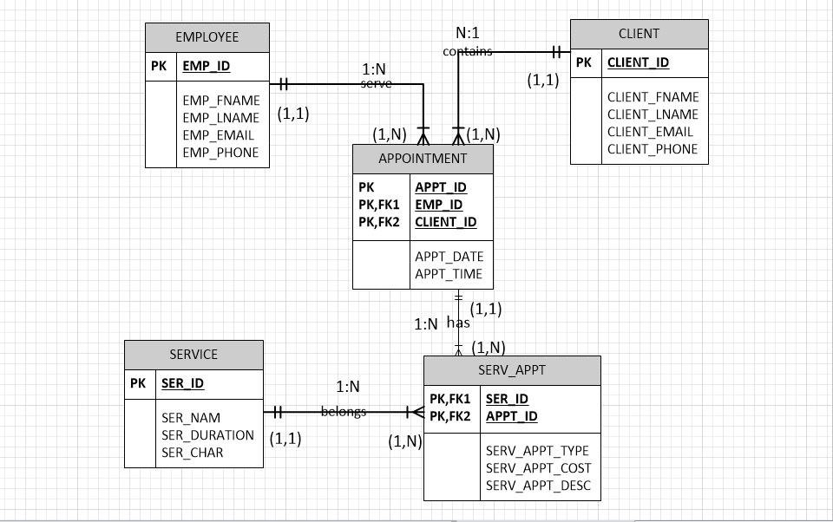

After Fixing with Notes:

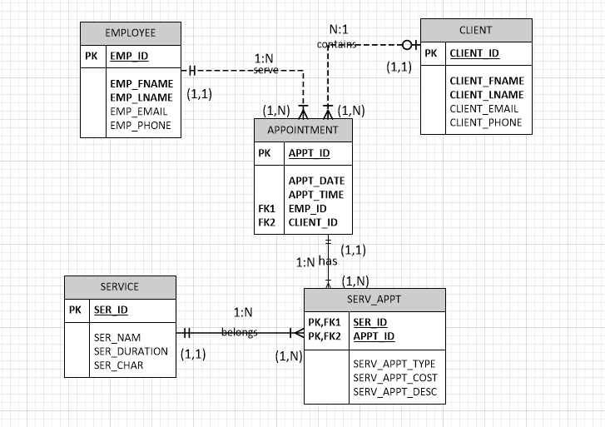

3- a. Chose Database: - use balswyan;

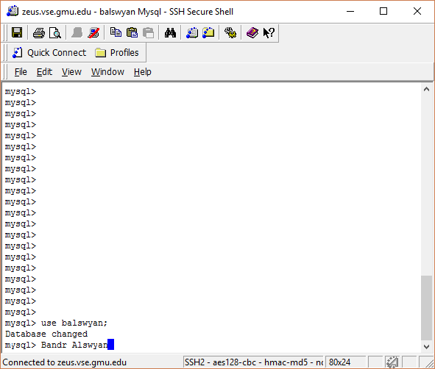

b. - CREATE TABLE EMPLOYEE(EMP_ID INT NOT NULL,EMP_FNAME varchar(20) NOT NULL,EMP_LNAME varchar(20),EMP_EMAIL varchar(50),EMP_PHONE varchar(20),PRIMARY KEY(EMP_ID));

DESC EMPLOYEE;

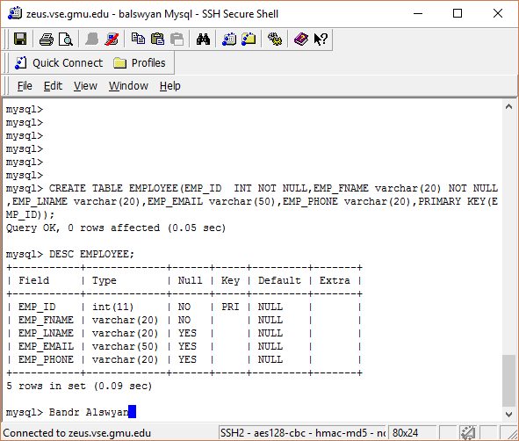

* CREATE TABLE CLIENT(CLIENT_ID INT NOT NULL,CLIENT_FNAME varchar(20) NOT NULL,CLIENT_LNAME varchar(20),CLIENT_EMAIL varchar(50),CLIENT_PHONE varchar(20),PRIMARY KEY(CLIENT_ID));

Desc CLIENT;

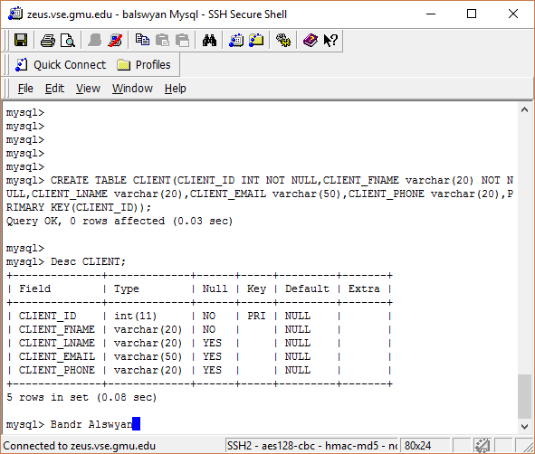

* CREATE TABLE APPOINTMENT(APPT_ID INT NOT NULL,APPT_DATE date,APPT_TIME time,EMP_ID INT,CLIENT_ID INT,PRIMARY KEY(APPT_ID),FOREIGN KEY(EMP_ID) REFERENCES EMPLOYEE(EMP_ID),FOREIGN KEY(CLIENT_ID) REFERENCES CLIENT(CLIENT_ID));

Desc APPOINTMENT;

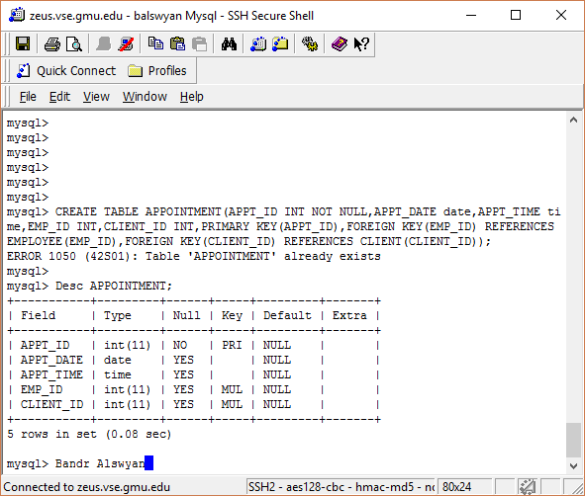

* CREATE TABLE SERVICES(SER_ID INT NOT NULL, SER_NAME varchar(20) NOT NULL, SER_DURATION varchar(20),SER_CHAR varchar(20), PRIMARY KEY(SER_ID));

Desc SERVICES;

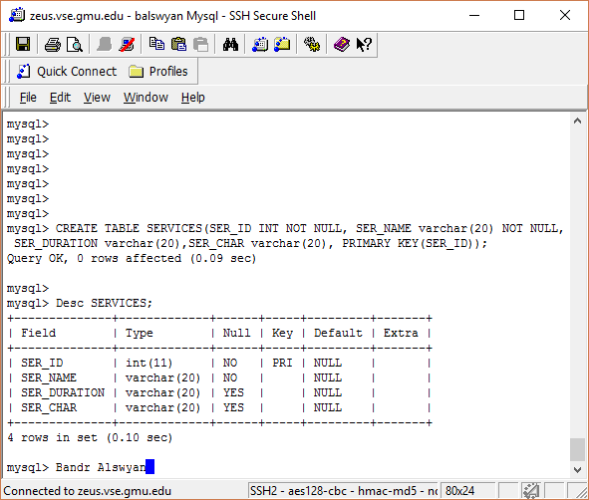

* CREATE TABLE SERV_APPT(SER_ID INT NOT NULL, APPT_ID INT NOT NULL, SERV_APPT_TYPE varchar(50), SERV_APPT_COST decimal(10,2), SERV_APPT_DESC varchar(50), FOREIGN KEY (SER_ID) REFERENCES SERVICES(SER_ID), FOREIGN KEY (APPT_ID) REFERENCES APPOINTMENT(APPT_ID));

DESC SERV_APPT;

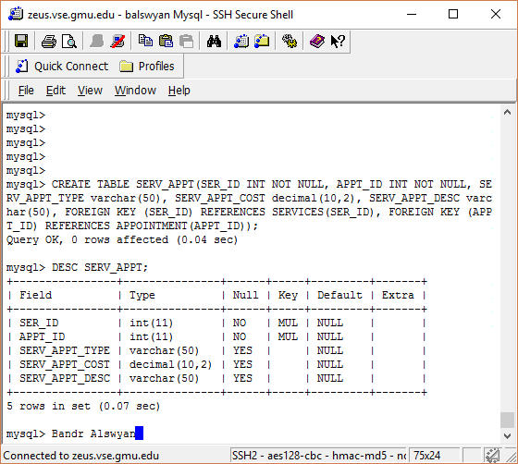

C. - INSERT INTO EMPLOYEE (EMP_ID,EMP_FNAME,EMP_LNAME,EMP_EMAIL,EMP_PHONE)

VALUES (1,'David','Charlie','david@mail.in',6183893933),(2,'Jack','Martin','jack@mail.in',6189375858),(3,'John','Duild','john@mail.in',6185885858),(4,'Ammy','Joseph','ammy@mail.in',6189375858);

* INSERT INTO CLIENT(CLIENT_ID,CLIENT_FNAME,CLIENT_LNAME,CLIENT_EMAIL,CLIENT_PHONE)

VALUES (1,'James','Charlie','charlie@mail.in',6188848933),(2,'Rocky','John','rocky@mail.in',6174848448),(3,'Donald','Perth','donald@mail.in',6185885858),(4,'Masy','Joseph','masy@mail.in',6189375858);

* INSERT INTO APPOINTMENT (APPT_ID,APPT_DATE,APPT_TIME,EMP_ID,CLIENT_ID)

VALUES (1,'2016-10-14','02:23:10',1,2),(2,'2016-9-19','04:24:15',2,2),(3,'2016-10-16','05:26:20',3,1),(4,'2016-10-18','03:46:09',4,4);

* INSERT INTO SERVICES (SER_ID,SER_NAME,SER_DURATION,SER_CHAR)

VALUES (1,'Joseph','2 hrs','hc'),(2,'Charlie','1 hr','sc'),(3,'Rocky','3 hrs','hsc'),(4,'Mary','1 hr','hc');

* INSERT INTO SERV_APPT(SER_ID,APPT_ID,SERV_APPT_TYPE,SERV_APPT_COST,SERV_APPT_DESC)

VALUES (2,1,'Hair cutting','200','test'),(4,3,'Step cutting','300','test'),(3,2,'Hair cutting','450','test'),(4,2,'Hair step cutting','500','test');

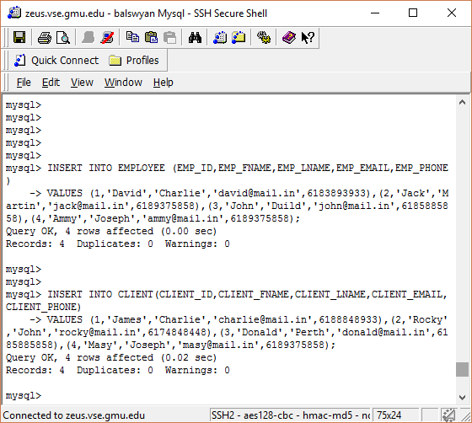

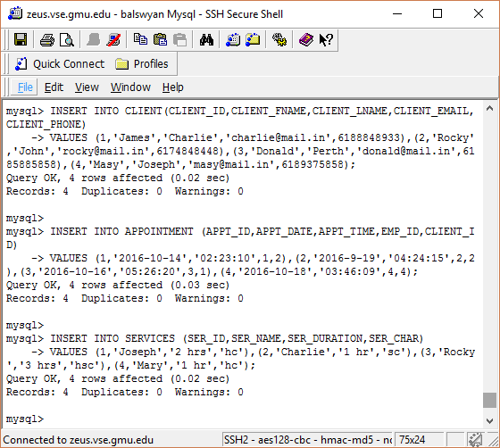

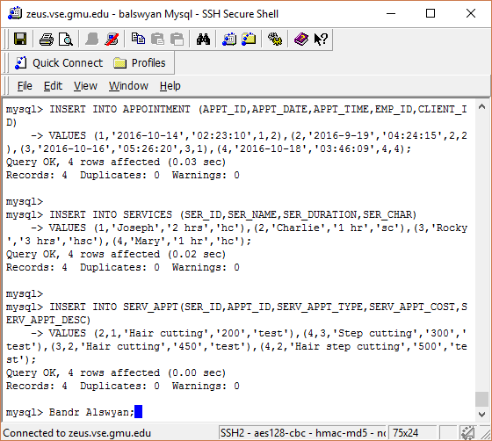

* SELECT * FROM EMPLOYEE;

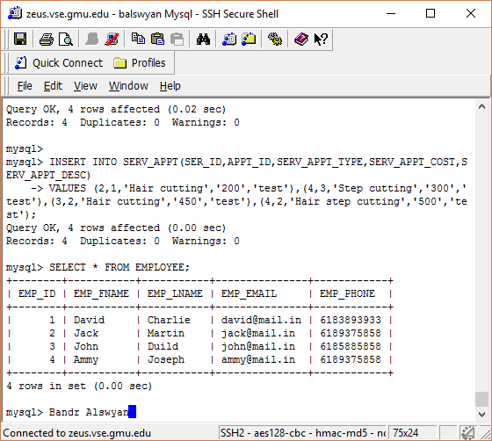

* SELECT * FROM APPOINTMENT;

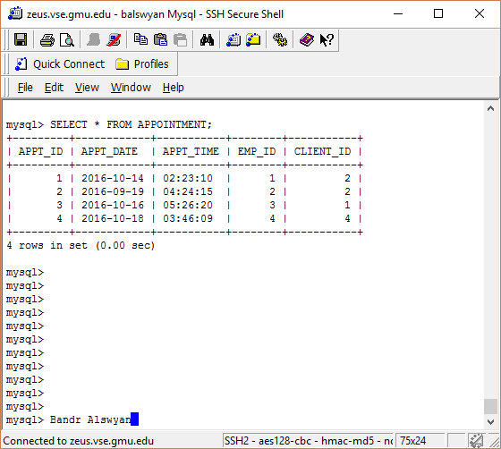

* SELECT * FROM CLIENT;

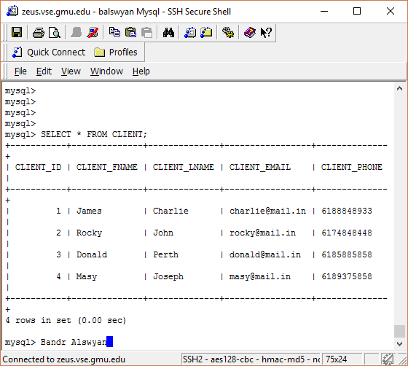

* SELECT * FROM SERV_APPT;

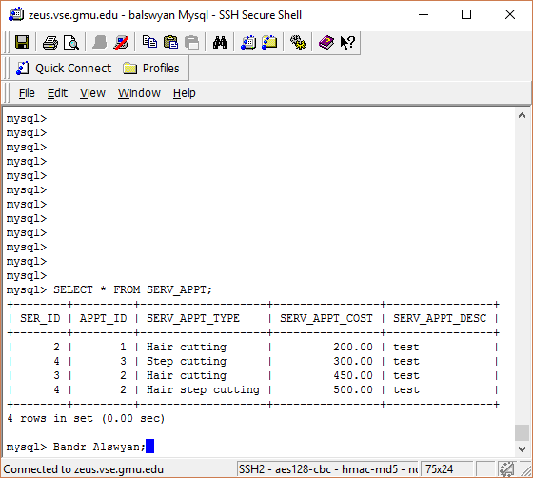

* SELECT * FROM SERVICES;

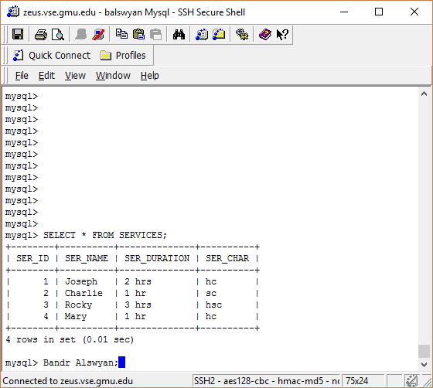

4-

a. SELECT A.*,C.CLIENT_FNAME FROM APPOINTMENT A LEFT OUTER JOIN CLIENT C ON A.CLIENT_ID=C.CLIENT_ID where A.APPT_DATE > '2016-10-14' ;

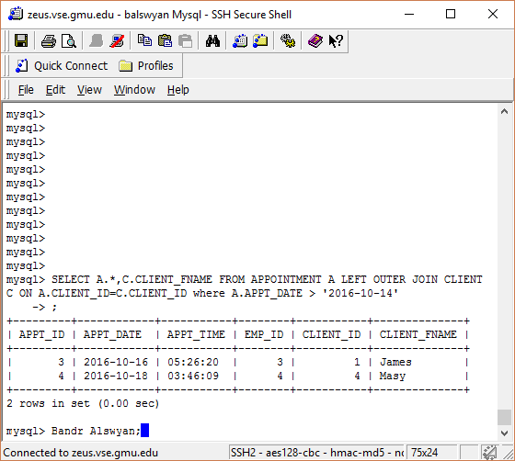

b. SELECT MAX(SA.SERV_APPT_COST),A.APPT_DATE,(A.APPT_ID+SA.SER_ID) As ID_SUM FROM APPOINTMENT A LEFT OUTER JOIN SERV_APPT SA

On SA.APPT_ID=A.APPT_ID WHERE A.APPT_DATE <= '2016-10-14' ORDER BY APPT_DATE ASC;

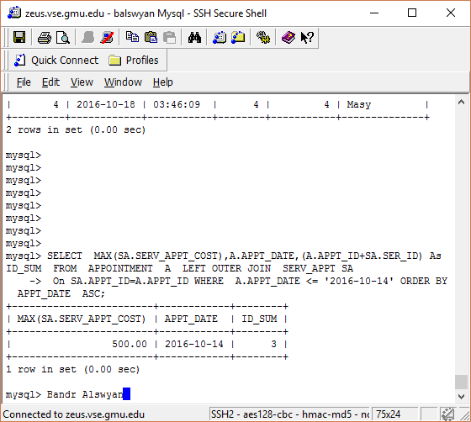

c. SELECT * FROM APPOINTMENT WHERE APPT_ID IN (SELECT APPT_ID FROM APPOINTMENT WHERE APPT_DATE > '2016-10-14') ;

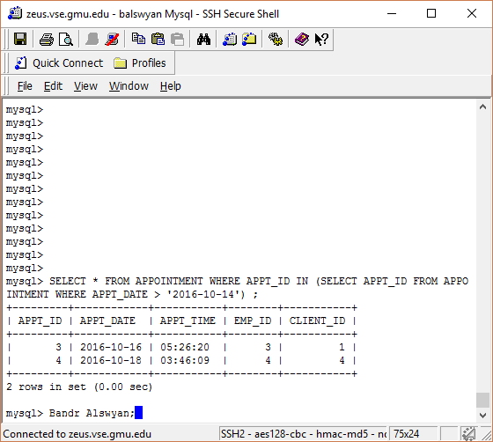

d. SELECT E.EMP_FNAME,COUNT(A.APPT_ID) FROM EMPLOYEE E LEFT JOIN APPOINTMENT A ON E.EMP_ID=A.EMP_ID WHERE A.APPT_DATE='2016-10-14' GROUP BY A.APPT_TIME HAVING COUNT(A.APPT_ID) > 2 ;

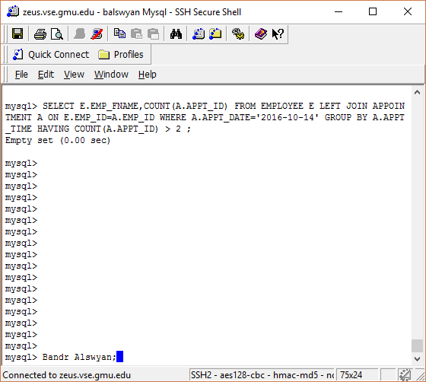

e. SELECT A.APPT_ID, DATE_FORMAT(A.APPT_DATE, "%W, %d/%m/%Y" ), E.EMP_FNAME,E.EMP_EMAIL FROM EMPLOYEE E LEFT OUTER JOIN APPOINTMENT A

On E.EMP_ID=A.APPT_ID LEFT OUTER JOIN CLIENT C ON C.CLIENT_ID=A.APPT_ID WHERE A.APPT_DATE > '2016-10-14' ORDER BY APPT_DATE ASC;

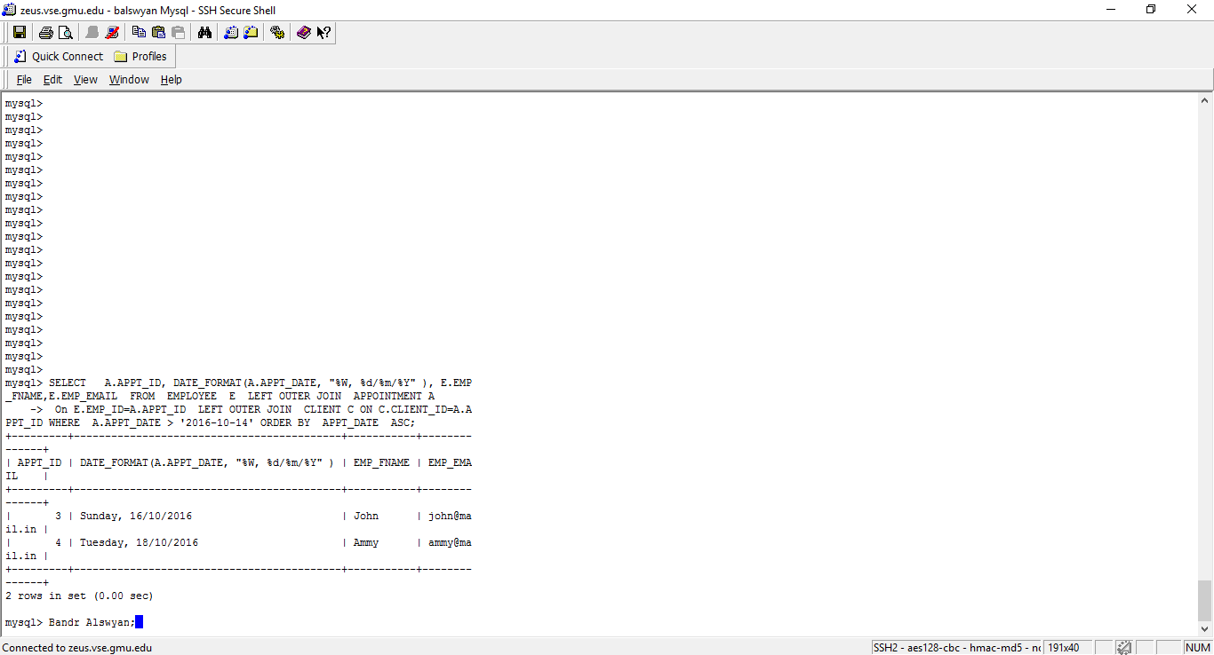

SELECT MAX(SA.SERV_APPT_COST),A.APPT_DATE FROM APPOINTMENT A LEFT OUTER JOIN SERV_APPT SA

On SA.APPT_ID=A.APPT_ID WHERE A.APPT_DATE <= '2016-10-14' ORDER BY APPT_DATE ASC;

**Explanation:**

First complex query find result from two tables. Table names are EMPLOYEE and APPOINTMENT with help of this query we are getting appointment id(APPT_ID), Appointment date(APPT_DATE) in our specific date format, Employee first name(EMP_FNAME), Employee email(EMP_EMAIL). We are using Left outer join to join these two tables to get combined result from these two tables. We are also gives certain condition to get result like AAPT_DATE greater than 2016-10-14. We are getting result in APPT_DATE in ascending order.

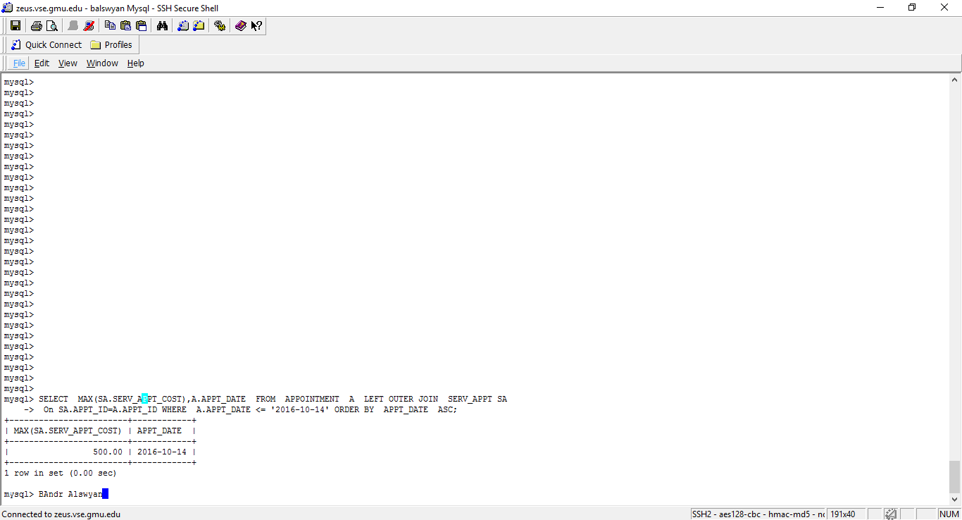

**Explanation:**

Second Complex query find result from three tables EMPLOYEE,APPOINTMENT and CLIENT. We are using Left outer join with three tables. We are getting result APPT_ID,EMP_FNAME,EMP_EMAIL,APPT_DATE, sum of 2 Ids like APPT_ID and CLIENT_ID where APPT_DATE is greater than and equal to 2016-10-14 and APPT_TIME is equal to 04:24:15 and our result in order by APPT_DATE in ascending order.